Lab 7 - Configure Basic IPv4 Connectivity
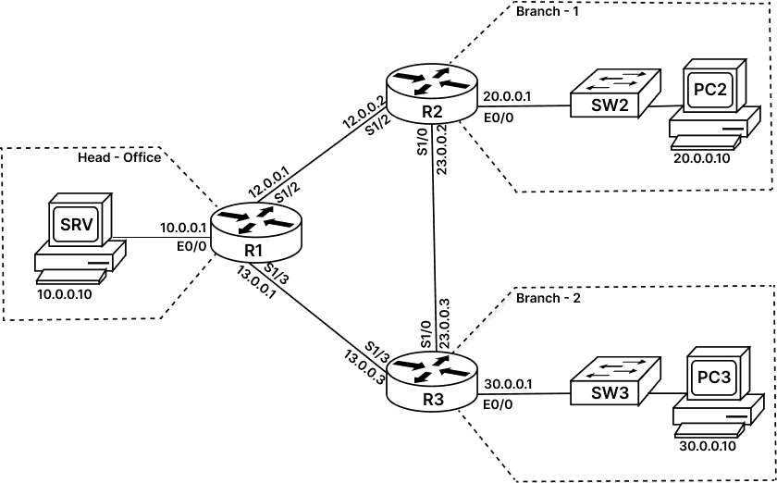

Task 1: Configure IPv4 Addresses on Branch Routers:
In this task, we will configure IPv4 addresses on all relevant Interface of each branch router (R2, R3) and Head-office router (R1).
LAN Equipment’s like Switches (SW2 and SW3) and all branch computers (PC-02 and PC-03) and Server (SRV) are pre-configured with IP addresses, default-gateways, usernames, passwords, and all other configurations.
Step 1: Access the console of Head-office router R1 and enter interface config mode to configure IPv4 addresses as seen in diagram. Use the following command:
Note: Password for privilege EXEC mode is 'cisco'
R1> enable
R1# config terminal
R1(config)# interface ethernet0/0
R1(config-if)# ip address 10.0.0.1 255.255.255.0
R1(config-if)# no shutdown
R1(config-if)# exit
R1(config-if)# interface serial1/2
R1(config-if)# ip address 12.0.0.1 255.255.255.0
R1(config-if)# no shutdown
R1(config-if)# exit
R1(config-if)# interface serial1/3
R1(config-if)# ip address 13.0.0.1 255.255.255.0
R1(config-if)# no shutdown
R1(config-if)# end
R1#
Step 2: Access the console of R2 Branch-1 router and enter interface config mode to configure IPv4 addresses as seen in diagram. Use the following command:
Note: Password for privilege EXEC mode is 'cisco'
R2> enable
R2# config terminal
R2(config)# interface ethernet0/0
R2(config-if)# ip address 20.0.0.1 255.255.255.0
R2(config-if)# no shutdown
R2(config-if)# exit
R2(config-if)# interface serial1/2
R2(config-if)# ip address 12.0.0.2 255.255.255.0
R2(config-if)# no shutdown
R2(config-if)# exit
R2(config-if)# interface serial1/0
R2(config-if)# ip address 23.0.0.2 255.255.255.0
R2(config-if)# no shutdown
R2(config-if)# end
R2#
Step 3: Access the console of R3 Branch-2 router and enter interface config mode to configure IPv4 addresses as seen in diagram. Use the following command:
Note: Password for privilege EXEC mode is 'cisco'
R3> enable
R3# config terminal
R3(config)# interface ethernet0/0
R3(config-if)# ip address 30.0.0.1 255.255.255.0
R3(config-if)# no shutdown
R3(config-if)# exit
R3(config-if)# interface serial1/3
R3(config-if)# ip address 13.0.0.3 255.255.255.0
R3(config-if)# no shutdown
R3(config-if)# exit
R3(config-if)# interface serial1/0
R3(config-if)# ip address 23.0.0.3 255.255.255.0
R3(config-if)# no shutdown
R3(config-if)# end
R3#
Task 2: Verify Configuration:
Step 1: Access the console of R1 router and enter the Privilege EXEC mode. Verify the IPv4 configuration using following command:
R1# show ip interface brief

Interface IP-Address OK? Method Status Protocol
Ethernet0/0 10.0.0.1 YES manual up up
Ethernet0/1 unassigned YES TFTP administratively down down
Ethernet0/2 unassigned YES TFTP administratively down down
Ethernet0/3 unassigned YES TFTP administratively down down
Serial1/0 unassigned YES TFTP administratively down down
Serial1/1 unassigned YES TFTP administratively down down
Serial1/2 12.0.0.1 YES manual up up
Serial1/3 13.0.0.1 YES manual up up

R1#ping 12.0.0.2
Type escape sequence to abort.
Sending 5, 100-byte ICMP Echos to 12.0.0.2, timeout is 2 seconds:
!!!!!
Success rate is 100 percent (5/5), round-trip min/avg/max = 8/8/9 ms

R1#ping 13.0.0.3
Type escape sequence to abort.
Sending 5, 100-byte ICMP Echos to 13.0.0.3, timeout is 2 seconds:
!!!!!
Success rate is 100 percent (5/5), round-trip min/avg/max = 7/8/9 ms

R1#ping 10.0.0.10
Type escape sequence to abort.
Sending 5, 100-byte ICMP Echos to 10.0.0.10, timeout is 2 seconds:
!!!!!
Success rate is 100 percent (5/5), round-trip min/avg/max = 1/1/1 ms
Step 2: Access the console of R2 router and enter the Privilege EXEC mode. Verify the IPv4 configuration using following command:
R2# show ip interface brief

Interface IP-Address OK? Method Status Protocol
Ethernet0/0 20.0.0.1 YES manual up up
Ethernet0/1 unassigned YES TFTP administratively down down
Ethernet0/2 unassigned YES TFTP administratively down down
Ethernet0/3 unassigned YES TFTP administratively down down
Serial1/0 23.0.0.2 YES manual up up
Serial1/1 unassigned YES TFTP administratively down down
Serial1/2 12.0.0.2 YES manual up up
Serial1/3 unassigned YES TFTP administratively down down

R2#ping 12.0.0.1
Type escape sequence to abort.
Sending 5, 100-byte ICMP Echos to 12.0.0.1, timeout is 2 seconds:
!!!!!
Success rate is 100 percent (5/5), round-trip min/avg/max = 8/8/9 ms

R2#ping 23.0.0.3
Type escape sequence to abort.
Sending 5, 100-byte ICMP Echos to 23.0.0.3, timeout is 2 seconds:
!!!!!
Success rate is 100 percent (5/5), round-trip min/avg/max = 8/8/8 ms

R2#ping 20.0.0.10
Type escape sequence to abort.
Sending 5, 100-byte ICMP Echos to 20.0.0.10, timeout is 2 seconds:
!!!!!
Success rate is 100 percent (5/5), round-trip min/avg/max = 1/1/1 ms
Step 3: Access the console of R1 router and enter the Privilege EXEC mode. Verify the IPv4 configuration using following command:
R3# show ip interface brief

Interface IP-Address OK? Method Status Protocol
Ethernet0/0 30.0.0.1 YES manual up up
Ethernet0/1 unassigned YES TFTP administratively down down
Ethernet0/2 unassigned YES TFTP administratively down down
Ethernet0/3 unassigned YES TFTP administratively down down
Serial1/0 23.0.0.3 YES manual up up
Serial1/1 unassigned YES TFTP administratively down down
Serial1/2 unassigned YES TFTP administratively down down
Serial1/3 13.0.0.3 YES manual up up

R3#ping 13.0.0.1
Type escape sequence to abort.
Sending 5, 100-byte ICMP Echos to 13.0.0.1, timeout is 2 seconds:
!!!!!
Success rate is 100 percent (5/5), round-trip min/avg/max = 8/8/9 ms

R3#ping 23.0.0.2
Type escape sequence to abort.
Sending 5, 100-byte ICMP Echos to 23.0.0.2, timeout is 2 seconds:
!!!!!
Success rate is 100 percent (5/5), round-trip min/avg/max = 8/8/9 ms

R3#ping 30.0.0.10
Type escape sequence to abort.
Sending 5, 100-byte ICMP Echos to 30.0.0.10, timeout is 2 seconds:
!!!!!
Success rate is 100 percent (5/5), round-trip min/avg/max = 1/1/1 ms

